Exercises for sciatica
This exercise routine is designed to help relieve sciatica – a pain caused by the irritation or compression of the sciatic nerve.
The sciatic nerve runs from the back of your pelvis, through your buttocks, all the way down both legs, ending at your feet.
These stretches from physiotherapist and BackCare expert Nick Sinfield help to mobilise the sciatic nerve and improve low back flexibility.
When starting out, go gently to get used to the movements and work out how far you can go into each position without feeling pain.
Aim to do this routine at least once a day if the pain allows. You can complement this routine with walking, cycling and water-based activities.
You are advised to seek medical advice before starting these exercises for sciatica, and to stop immediately if you feel any pain.

Knee to chest stretch
Improves the flexibility of your low back
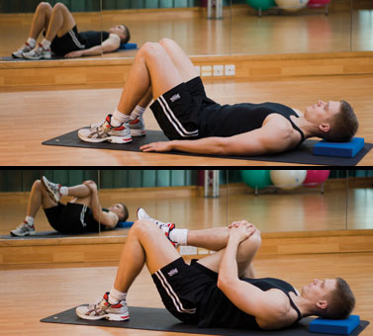
Start position: Lie on your back on a mat or the carpet. Place a small flat cushion or book under your head. Bend your knees and keep your feet straight and hip-width apart. Keep your upper body relaxed and your chin gently tucked in.
Action: Bend one knee up towards your chest and grasp your knee with both hands. Slowly increase this stretch as comfort allows. Hold for 20-30 seconds with controlled deep breaths.
Repeat three times, alternating legs.
Tips:
- Do not tense up through the neck, chest or shoulders.
- Only stretch as far as is comfortable.
Variation: Grasp both knees and press into chest.

Sciatic mobilising stretch
Mobilises the sciatic nerve and hamstrings
Start position: Lie on your back. Place a small flat cushion or book under your head. Bend your knees and keep your feet straight and hip-width apart. Keep your upper body relaxed and your chin gently tucked in.
Action: Bend one knee up towards your chest and grasp your hamstring with both hands. Slowly straighten the knee while bringing your foot towards you. Hold for 20-30 seconds, taking deep breaths. Bend the knee and return to the starting position.
Repeat two or three times, alternating legs.
Tips:
- Don't press your low back down into the floor as you stretch.
- Only stretch as far as is comfortable, and stop immediately if you feel any pain, numbness or tingling.

Back extensions
Stretches and mobilises the spine backwards
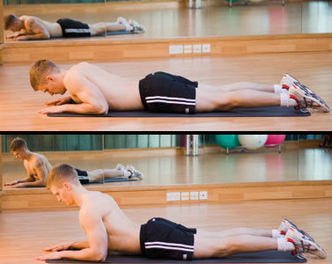
Start position: Lie on your stomach, and prop yourself on your elbows, lengthening your spine. Keep your shoulders back and neck long.
Action: Keeping your neck long, arch your back up by pushing down on your hands. You should feel a gentle stretch in the stomach muscles as you arch up. Breathe and hold for 5 to 10 seconds. Return to the starting position.
Repeat 8 to 10 times.
Tips:
- Don't bend your neck backwards.
- Keep your hips grounded.
- Only extend as far as is comfortable.

Standing hamstring stretch
Stretches and lengthens the hamstring muscles
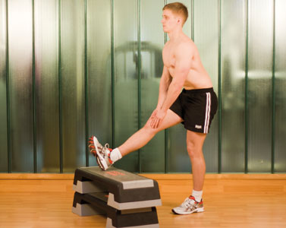
Start position: Stand upright and raise one leg on to a stable object, such as a step. Keep that leg straight and your toes pointing straight up.
Action: Lean forward while keeping your back straight. Hold for 20-30 seconds while taking deep breaths.
Repeat two to three times with each leg.
Tips:
- Only stretch as far as is comfortable.
- Your low back should not arch at any time.

Lying deep gluteal stretch
Stretches and lengthens the piriformis muscle
Start position: Lie on your back. Place a small flat cushion or book under your head. Bend your left leg and rest your right foot on your left thigh.
Action: Grasp your left thigh and pull it towards you. Keep your tailbone on the floor throughout and your hips straight. You should feel the stretch in the right buttock. Hold for 20-30 seconds, while taking deep breaths.
Repeat two to three times.
Tips:
- Use a towel around your thigh if you can't hold it.
- Do not let your tailbone come off the floor.
- Keep your pelvis straight (in a neutral position).

